**Exercise 3 - Installing and Configuring Drupal**

In this exercise, you will install and configure the Drupal CMS in the Linux virtual machine. At the end of the exercise, you will be able to host a Drupal CMS website.

**Note:** Before starting this exercise, make sure you have completed Exercise 2.

**Task 1 - Installing and Configuring Drupal**

In this task, you will install and configure a Drupal portal on your Microsoft Azure Linux Virtual Machine. Additionally, you will create an empty database to be used by Drupal CMS.

1. Open the root websites folder and create a folder named **Drupal** by executing the following.
2. cd /srv/www/htdocs
3. mkdir drupal
4. cd drupal
5. Execute the following command to install **wget**.

zypper install wget

1. Download and extract **Drupal**.
2. wget http://ftp.drupal.org/files/projects/drupal-7.37.tar.gz
3. tar -xzf drupal-7.22.tar.gz --strip-components=1

[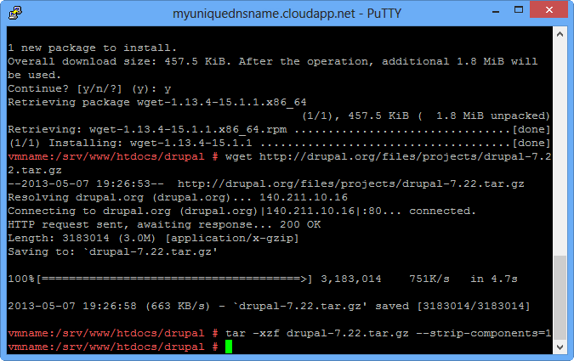](https://github.com/Azure-Readiness/MicrosoftAzureTrainingKit/blob/master/HOLs/HOL-IntroToWindowsAzureVirtualMachinesLinux/Images/downloading-drupal.png?raw=true)

*Downloading Drupal*

1. Copy the **default.settings.php** file, located in the **sites/default** directory, and rename the copied file to**settings.php**. Additionally, give the web server write privileges to the configuration file.
2. cp sites/default/default.settings.php sites/default/settings.php
3. chmod a+w sites/default/settings.php
4. chmod a+w sites/default

[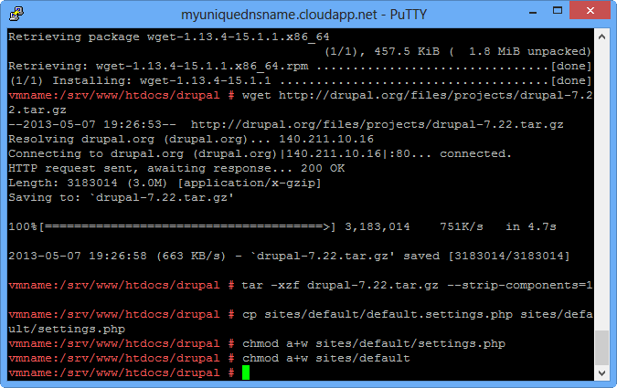](https://github.com/Azure-Readiness/MicrosoftAzureTrainingKit/blob/master/HOLs/HOL-IntroToWindowsAzureVirtualMachinesLinux/Images/creating-the-configuration-file-and-granting.png?raw=true)

*Creating the configuration file and granting permissions*

1. To complete the installation, create an empty database for **Drupal** in **MySQL**. Execute the following:
2. mysqladmin create drupaldb
3. Execute **mysql** command. At the MySQL prompt execute the following query. Replace **username** and **password** with your user account.

GRANT SELECT, INSERT, UPDATE, DELETE, CREATE, DROP, INDEX, ALTER, CREATE TEMPORARY TABLES, LOCK TABLES

ON drupaldb.*

TO 'username'@'localhost' IDENTIFIED BY 'password';

[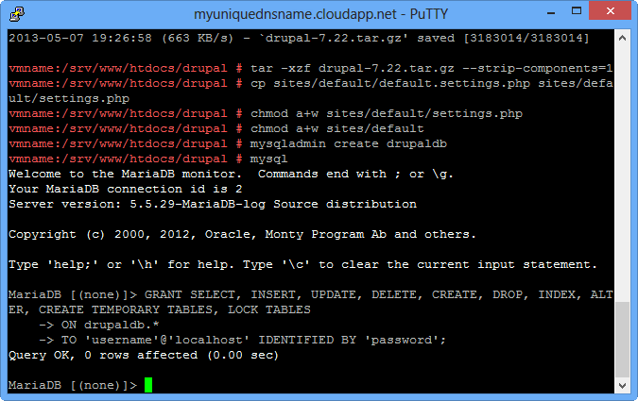](https://github.com/Azure-Readiness/MicrosoftAzureTrainingKit/blob/master/HOLs/HOL-IntroToWindowsAzureVirtualMachinesLinux/Images/granting-permissions-in-mysql.png?raw=true)

*Granting permissions in MySQL*

1. Open Internet Explorer and locate the virtual machine DNS Name. Browse to *http://[YOUR-DNS-URL]/drupal* to complete Drupal installation.

[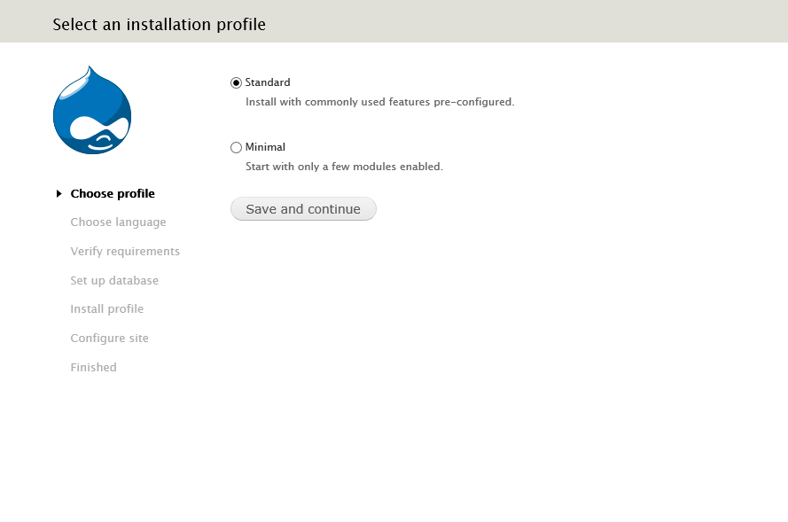](https://github.com/Azure-Readiness/MicrosoftAzureTrainingKit/blob/master/HOLs/HOL-IntroToWindowsAzureVirtualMachinesLinux/Images/opening-drupal-for-the-first-time.png?raw=true)

*Opening Drupal for the first time*

**Note:** You can find more details about Drupal configuration in the official documentation (<http://drupal.org/documentation/install/run-script>).

1. In the Set up Database page, enter the name of the database you have created in Task 1 (‘drupaldb’), and the **username\*** and **password\***.

[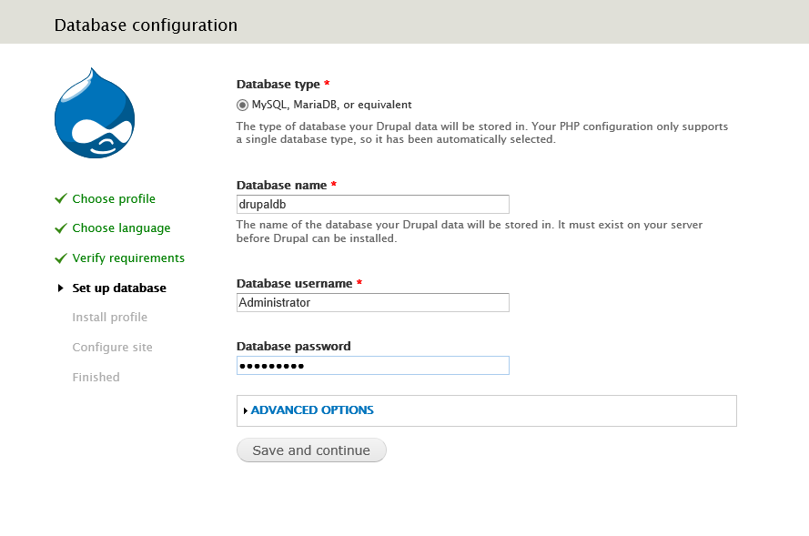](https://github.com/Azure-Readiness/MicrosoftAzureTrainingKit/blob/master/HOLs/HOL-IntroToWindowsAzureVirtualMachinesLinux/Images/opening-drupal-for-the-first-time2.png?raw=true)

*Opening Drupal for the first time*

*(*) MySql default username is 'root' and by default there is no password*

1. In the **Configure site** website, enter a user name, an e-mail address and a password to create a new **site maintenance account**.

[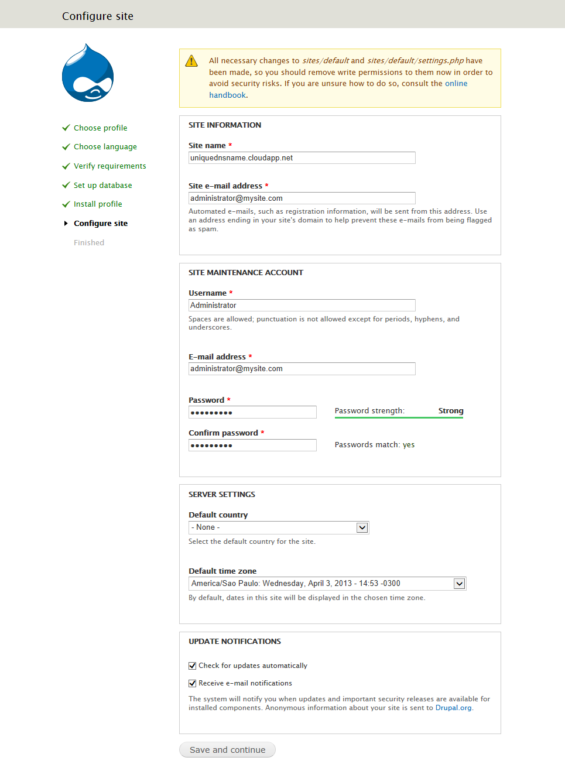](https://github.com/Azure-Readiness/MicrosoftAzureTrainingKit/blob/master/HOLs/HOL-IntroToWindowsAzureVirtualMachinesLinux/Images/configuring-a-drupal-account.png?raw=true)

*Configuring a Drupal account*

1. Click the **Visit your new site** link to verify that the Drupal home page loads.

[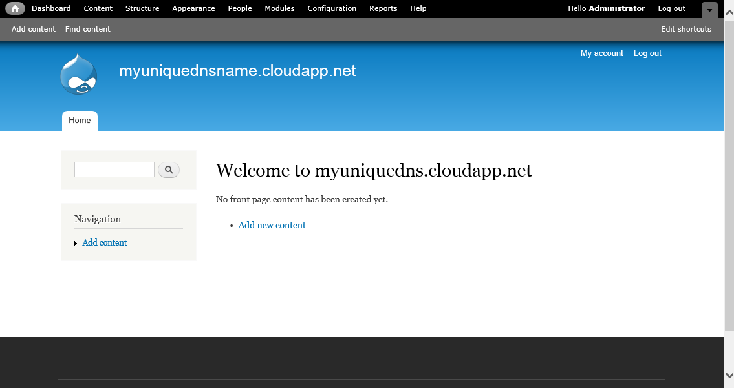](https://github.com/Azure-Readiness/MicrosoftAzureTrainingKit/blob/master/HOLs/HOL-IntroToWindowsAzureVirtualMachinesLinux/Images/drupal-cms-home-page.png?raw=true)

*Drupal CMS home page*